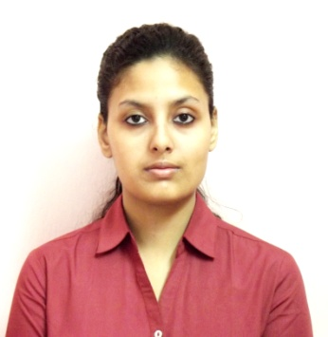**PAYEL CHAKRABORTY**

Phone- 8334987722 [Email-chakrabortypayel1991@gmail.com](mailto:Email-chakrabortypayel1991@gmail.com)

Address: 18/1, Bhattacharya Para lane, Howrah-711104, P.O-Santragachi

OBJECTIVE

Willing to put myself in a growth oriented organization to apply my growing knowledge and skill to contribute significantly for the company and to enhance my experience.

WORK EXPERIENCE

2017 Working as Retail Executive at ABP PVT LTD

* Job Role:
* Managing Offline store for sales& service
* Manage relationship and develop and execute alliances with other offline partners in store catchment area
* Achieve sales and service related targets
* Execute awareness, activation, engagement, sales events and initiatives in store catchment area
* Ensure quality of service is maintained while selling
* Ensure defined process are followed during sales activities
* Provide customer feedback to management
* Improve processes to reduce costs, time and enhance revenue
* Manage fresh sales and renewals

Previously worked as Telemarketing Executive at Matrimony.Com Ltd. For 9 months

Total year of experience: 2 year

EDUCATIONAL QUALIFICATION

2015 MBA (Marketing) from Techno India, Salt Lake under WBUT.

2012 B.Sc (Botany) from Jogamaya Devi College under CU.

2009 Higher Secondary Examination from Santragachi Kedarnath Institution under WBCHSE.

2007 Madhyamik Examination from Santragachi Kedarnath Institution under WBBSE.

TECHNICAL SKILLS

* Microsoft Office (MS-Word, MS-PowerPoint, MS-Excel)
* HTML

SUMMER INTERNSHIP PROJECT

* Organization- Mother Dairy Calcutta
* Title of the Project: A study of consumer perception about the brand Mother Dairy Calcutta and analysis of distribution channel.
* Time period- 2 month

LANGUAGES KNOWN

English, Bengali, Hindi

EXTRA CURRICULAR ACTIVITIES

* 1998-99, Junior Diploma part-2 in Art (1st division) from Sarbo Bharatiya Sangeet and Sanaskrit Parishad (Recognized by West Bengal State Academy of Dance, Drama, Music & Fine Arts. Registered under West Bengal Societies Registration Act XXVI of 1961)
* 2002-2003, Senior Diploma part-2 in Art (1st division) from Bharatiya Sangeet Academy (Registered under West Bengal Societies Registration Act XXVI of 1961)

ACHIEVEMENTS

* 2006, Certificate for the participation and performance in the social service programme conducted by Blind Persons’ Association.
* 2006, Certificate for the performance in Talent Search test on Geography from Bangiyo Bhugol Mancha.
* 2007, Certificate for the performance in Madhyamik Examination from Howrah Municipal Corporation.

HOBBIES

Listening to music, Singing, Drawing.

PERSONAL INFORMATION

* Date of Birth-24/09/1991
* C/o-Mrs. Krishna Chakraborty
* Nationality-Indian
* Caste-Hindu, General
* Marital Status-Unmarried
* Sex-Female